UNIT TWO
African Empires & Civilizations Project
DUE BY TUESDAY – SEPTEMBER 22
Select one of the following to research in order to write a 1-2 page typed report. You must cite the source(s) of where you got your information from. If you are going to quote someone or use their words, make sure that you give proper credit.
DO NOT COPY AND PASTE OR PLAGIARIZE AN AUTHOR’S WORK - OR YOU WILL GET A ZERO !
If you need assistance in knowing how to give an author credit for their work….please ASK !
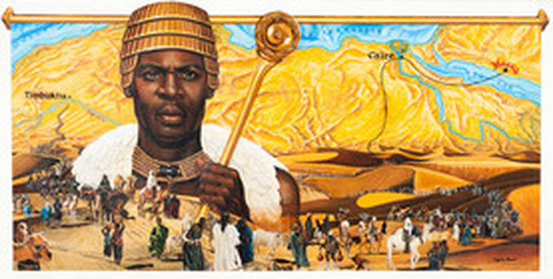

POSSIBLE TOPICS
- EGYPTIAN PHAROHS
- THE EMPIRE OF GHANA
- THE EMPIRE OF KUSH
- THE EMPIRE OF MALI featuring MANSA MUSA
- KING TUT
- AKHENETAN and NEFERTITI
- EGYPTIAN ARCHITECTURE
- THE EMPIRE OF SONGHAI
- THE EGYPTIAN PYRAMIDS

YOU MUST HAVE
- Size 12 font - double spaced - TIMES NEW ROMAN LETTERING

